Assignment 3 - Object Design Implementation and Reflection

Topic: Online Electronics Store (AWE Electronics - Online)

Executive Summary

The store owners of AWE Electronics have expressed an interest in expanding their operations online. Their current system is operating a local store situated at Glenferrie Road, limiting their reach to nearby suburbs encompassing the area. For this reason, the store owners of AWE Electronics have contacted Swinsoft Consulting to assess and develop the specifications required for a new Online Electronics Store system that will extend their reach to customers Australia-wide.

In Assignment 2, we have been given the task to come up an initial object-oriented design of An
Online Electronics Store. Based on that initial design, we have carried out a detailed design and implementation for the system. The purpose of this report is to reflect on the initial design based on our experience with the detailed design and implementation.

Table of Contents

Detailed Object-Oriented Design 4
Overview of Updated Class Details 4
Model Layer 5
View Layer 6
Controller Layer 7
Relationships 9
UML Class Diagram 10
Overall Changes 11
Changes to Responsibilities and Collaborators 11
Changes to Dynamic Aspects 13
Discussion of Assignment 2 Design 14
Good aspects 14
Missing from original design 14
Flawed aspects of original design 15
Level of interpretation required 15
Lessons Learnt 16
1. Design for Frameworks, Not Just for Abstraction 16
2. Start Simple, Evolve When Needed 16
3. Emphasize Collaboration and Flow, Not Just Entities 16
4. Validate Through Use Cases Early 16
Architecture Styles 17
Component Overview 17
Connections Between Components 17
Architectural Constraints 17
Implementation 18
YouTube Link to Implementation of Scenarios 18

Detailed Object-Oriented Design

Compared to the planned design in Assignment 2, the actual implementation of AWE Electronics retains the core business logic and primary domain entities (such as Product, User, and Order), while adapting the architecture to fit a realistic and maintainable Flask web application. The changes improve security, maintainability, and user experience by leveraging Flask's ecosystem.

Overview of Updated Class Details

Class | Status | Notes
Product | Implemented | Implemented in models.py with added fields: image_url, category, is_active.
Order | Implemented | Captures product, quantity, user, and transaction time. Central to checkout and invoice generation.
Delivery | Implemented | Stores address and minimal card/payment info.
User | Implemented | Unified class with role, is_admin_approved, admin_requested. Used for both customers and owners.
Authentication | Merged into User | Embedded in routes.py using Flask-Login and manual registration/login handling.  The User class will also handle this authentication utilising Flask.
Cart | Implemented | Connects users to products before checkout.
Customer | Merged into User | Removed as a subclass. User role (role='customer') used to distinguish behavior.
Owner | Merged into User | Same as above. Role-based access (role='owner') manages admin functionality.
ProductCatalogue | Logic integrated into views | Not implemented as a separate class; handled via database queries and templates (product_list.html).
Payment | Flattened into Delivery | No standalone Payment class. Card info is part of delivery form (validated, not stored in full).
OnlineStore | Conceptual only (Controller classes) | Not a real class in Flask; handled via route handlers (routes.py) and app factory logic.
SaleReport | Merged into Order | Order now handles this responsibility of holding sales information due to an Order not being able to be refunded.  Report is also generated via route logic and SQL queries.
ContactMessage | New Class | Handles contact form submissions, tracks is_read status for admin inbox.
Table 1. Overview of Updated Class Details

Model Layer
The Model Layer is directly responsible for the web applications data and business logic. It essentially contains attributes and methods which map to the data and logic of this application.

User Class
- Attributes: user_id (PK), name, email, password, role, is_admin_approved, admin_requested
- Methods: authenticate(), assign_role(), approve_admin(), request_admin()
- Responsibilities: Handles user authentication and user level of privileges e.g Owner gets access to admin dashboard and Customers get access to their shopping cart, check-out and orders.

Product Class
- Attributes: product_id (PK), name, price, description, image_url, category, is_active
- Methods: add_product(), delete_product(), edit_product(), deactivate_product(), activate_product(), get_product_id(), get_product_name(), get_product_price()
- Responsibilities: Manages product specific details such as the name, price, description, image, and whether it is available for the user to purchase or not.

Cart Class
- Attributes: cart_id (PK), user_id (FK), product_id (FK), quantity
- Methods: add_to_cart(), delete_from_cart()
- Responsibilities: Manages a list of selected products for a user (customer), and enables check-out upon item selection in cart.

Order Class
- Attributes: order_id (PK), user_id (FK), product_id (FK), quantity, transaction_date
- Methods: generate_sales_report(), calculate_total(),
- Responsibilities: Manages order specific details such as whos customer’s order, the products in the order, quantity of each product and the transaction date upon completion of the order. As orders cannot be refunded, it is also responsible for recording a sale.

Delivery Class
- Attributes: delivery_id (PK), user_id (FK), order_id (FK), address, city, postal_code, card_name, card_number
- Methods: process_payment()
- Responsibilities: Manages delivery and payment specific details upon check-out such as the customer, order number, address, city, postcode, and card details.

ContactMessage Class
- Attributes: contact_id (PK), name, email, subject, message, created_at, is_read, status
- Methods: mark_message_read(), delete_user_request(), get_admin_messages()
- Responsibilities: Manages the messages the customers send to the owner including details of the message and who it is from.

View Layer
The View Layer has the responsibility of providing an interface to the users, and is consequently the layer that the user will interact with. As this layer primarily deals with user input, it will also be responsible for input validation.

User Interface (UI)
- Registration Form: Allows new users to register for an account followed through with the correct information entered such as their name, email and password.
- Login Form: Allows users that have registered to log into their account by entering the correct details (email and password). The administrator/owner will also be logging in through the same portal.
- Home Page: The default home page upon entering the website and successfully logging in as a customer. It will feature recommended products and top sellers.
- Product List Page: This is the store catalogue where all the products available to be purchased will be shown. It will enable users to add products of their choice to their carts.
- Cart Page: Allows users to view their cart and check-out once they are satisfied with their selection.
- Check-out Page: Enables users to proceed with their order to payment processing by providing the necessary details such as their delivery address, postcode, city, and card information.
- Invoice Page: Shows the user an receipt and summary of their order after completing the check-out process.
- Owner Contact Message Form: Enables users to send a message to the admin/owner to review by entering the correct information such as their name, email, and contents of the message they wish to send.

Admin Interface
- Admin Dashboard Page: Provides the admin/owner with a list of specifics on product details and other operations.
  - Product Management: Enables the admin/owner to delete and deactivate/reactivate the current products. Also allows editing of the current product's details.
    - Add Product Page: A separate form which enables the admin/owner to add in another product by providing the necessary details such as name, price, description, image url, and category.
  - Sales Report Management: Enables the admin/owner to custom pick a date range of their choice and generate some basic statistics of goods sold within that specified period.
    - Sales Report Page: Allows the admin/owner to view the statistics within the chosen specified period.
  - Admin Management: Enables the admin/owner to approve and reject admin account privileges.
- Customer Contact Message Page: Allows the admin/owner to view the messages sent by the customer and mark as read.

Responsibilities:
- User-friendly: The user interface to the user will feel intuitive to use, with navigation around the website simple to traverse and processes easy to understand.
- Consistency: Views across the website will remain consistent in terms of design and cohesiveness. Users should not feel one way and another way in the next page.
- Validation: As this deals with user input, these will be validated prior to submissions to ensure that the correct data type and values are given by the users.

Controller Layer
The Controller Layer is responsible for responding to user input and performs business operations that are primarily centered around the modification of the state of the data model.

UserController
- Methods:
  - login(): Verifies the user’s identity and creates a session.
  - logout(): Terminates the session and redirects you back to the home page.
  - register(): Deals with user registration.
  - demote_admin(): Allows the admin/owner to demote approved admins.
  - approve_admin(): Allows the admin/owner to approve and promote their account to admin status.
  - delete_user_request(): Allows the admin/owner to delete the admin request.
Responsibilities: Handles requests related to both kinds of users (owner and customers), which also includes authentication.

ProductController
- Methods:
  - add_product(): Facilitates the creation of a new product by the admin/owner.
  - edit_product(): Allows updating of information on an existing product.
  - delete_product(): Handles the removal of a product.
  - filter_product(): Enables the user to select a category and filter products shown in the catalogue.
  - search_product(): Enables the user to input and search for products that match in the catalogue.
Responsibilities: Manages and handles information of a product.

CartController
- Methods:
  - add_to_cart(): Enables the user to add a product of their choice and add it to cart.
  - delete_from_cart(): Enables the user to remove a product from cart in the event they change their mind.
Responsibilities: Manages customer’s carts to accurately reflect what products they have queued up for check-out.

OrderController
- Methods:
  - generate_sales_report(): Enables the admin/owner to generate a sales report by taking in the date inputs they provide.
  - create_invoice(): Enables the customer to view an invoice receipt of their recent purchase upon order completion.
Responsibilities: Handles the recording of a sale, and manages the generation of invoices and sales reports.

DeliveryController
- Methods:
  - process_payment(): Handles the payment process for the customer’s order.
Responsibilities: Handles the payment processing and delivery details of a customer’s order.

ContactMessageController
- Methods:
  - submit_message(): Enables customers to send a message to the admin/owner.
  - view_message(): Enables the admin/owner to view the messages sent by the customers.
Responsibilities: Handles the submission and viewing of customer messages.

Relationships
- User (customer) to Cart: One-to-One relationship, where each user (customer) has their own shopping cart.
- User (customer) to Order: One-to-Many relationship, where each user (customer) can have multiple orders.
- User (admin/owner) to Product: One-to-Many relationship, where each user (owner) can modify multiple products.
- User (admin/owner) to Order: One-to-Many relationship, where each user (admin/owner) can view multiple orders.
- User to ContactMessage: One-to-Many relationship, where each user (customer) can send many messages. On the other hand, each user (admin/owner) can view multiple messages.
- Cart to Product: Zero-to-Many relationship, where each cart can have 0 or more products.
- Order to Product: One-to-Many relationship, where each order can have many products.
- Order to Delivery: One-to-One relationship, where for each order it will have delivery and payment information attached.

UML Class Diagram
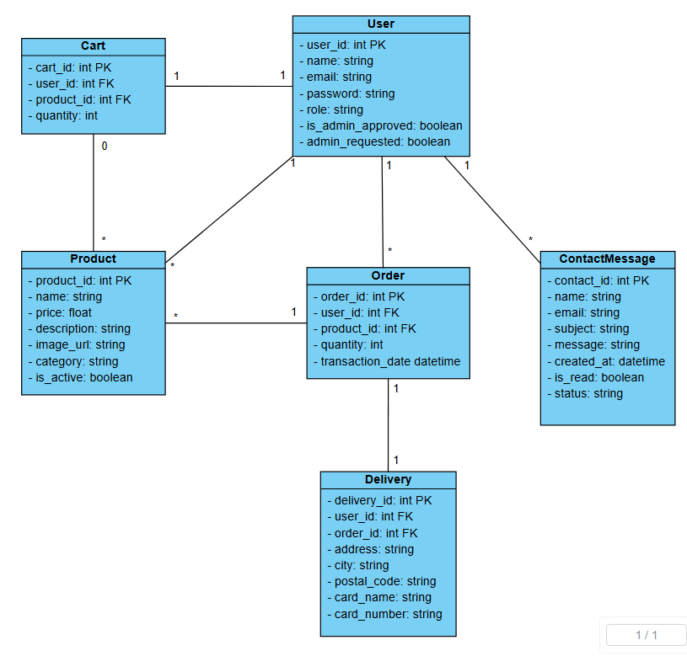
Figure 1. UML Class Diagram (with no methods)

Overall Changes

While the core structure remains recognizable, the following significant changes were made:
- Unified User Class: The User class now includes role, is_admin_approved, and admin_requested attributes, replacing the need for separate Customer and Owner subclasses. This simplifies role management using conditional logic.
- Removed ProductCatalogue Class: Product listing is handled via SQLAlchemy queries and dynamic rendering in templates like product_list.html, making the dedicated ProductCatalogue class redundant.
- Flattened Payment into Delivery: The Payment class was omitted; card information is collected via the delivery form and validated, but not stored, ensuring basic security and PCI compliance.
- Omitted SaleReport Class: Sales reporting is implemented directly through SQL queries within route functions, rather than as a separate model or service class.
- Extended Product Class: Additional fields such as image_url, category, and is_active were added to support UI rendering and allow admin control over product visibility.
- New ContactMessage Class: Introduced to manage customer inquiries through a contact form, this class tracks read/unread status and supports administrative message handling.

Changes to Responsibilities and Collaborators

- User Class

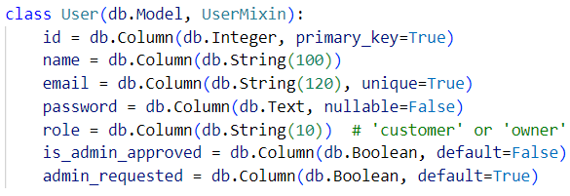
Figure 2. User Class
New Responsibilities:
- Role-based access control (customer vs. owner)
- Admin approval tracking
- Password hashing and validation
- Session management via Flask-Login
- Conditional view rendering based on current_user.role
- Flash messaging for user feedback
- Email uniqueness enforcement

- Product Class

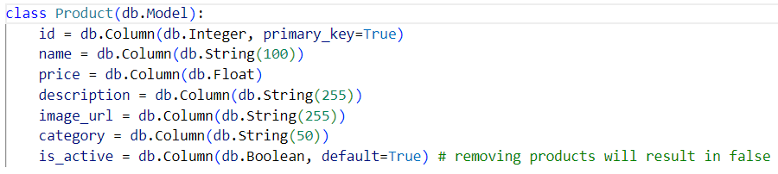
Figure 3. Product Class
New Responsibilities:
- Product status toggling with is_active
- Category tagging for filtering and presentation
- Image URL storage for dynamic product rendering
- Integration with admin dashboard for inline editing

- Cart Class

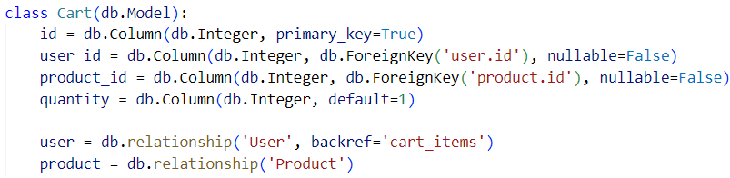
Figure 4. Cart Class
New Responsibilities:
- Direct database persistence of items
- Quantity tracking per user-product pair
- Manages user-specific product selection before checkout
- Effectively serves the role of a CartItem model through its structure

- ContactMessage Class (New)

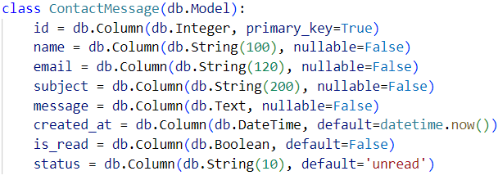
Figure 5. ContactMessage Class
New Responsibilities:
- Capture and store inquiries from customers
- Timestamp and status tracking (unread / read)
- Collaborates with admin dashboard for message review and action

Changes to Dynamic Aspects

Bootstrap and Initialisation:
- Replaced manual object creation with a Flask application factory pattern
- db.create_all() initialization handled through Flask-SQLAlchemy
- Modular routing using Flask Blueprints (main)
- User sessions and login management handled by Flask-Login
- Secure form submission (Flask-WTF ready, even if not currently used)

Interaction Scenarios:
- Dynamic behavior based on role (e.g., dashboard for owners, cart for customers)
- Form submissions handled with POST routes and database-bound models
- Flash messages used to provide feedback on actions like login, approval, or errors
- Session management ensures role-based navigation and personalized content
- Product status changes, admin approval actions, and report generation are interactive and responsive through route logic and Bootstrap-enhanced templates

Discussion of Assignment 2 Design

Good aspects
Our initial design from Assignment 2 addressed the majority of the things we had in mind upon diving deeper into the detailed design aspect. Specifically, this was seen through our initial design breakdown of each classes responsibilities, their collaborators and consequently how they are linked up together as a whole. This effectively brought and upheld the separation of concerns principle, making it a lot easier to visualise and see how the system will work as a base at a high-level before going into the attributes and methods each class will hold in the detailed design.

Missing from original design
Our initial design from Assignment 2 while it addressed the majority of the business operations, it did not address certain aspects we thought that was required to add as we went through the detailed design and implementation.

- Customer and owner communication: At the time of the initial design, there was no system that facilitated some form of communication between the customer and owner. To address this missing piece, we added a ‘ContactMessage’ class during our detailed design, which essentially bridges communication between the customer and owner by providing the means to do so.
- No clear architecture: Architecture was also something that was particularly missing at the time of our initial design. When planning the initial design, we did not have a clear idea on what sort of architecture we should adopt. However, in the detailed design and implementation of Assignment 3, we addressed this through the adoption of a modular architecture and design pattern; MVC. This was done through the introduction of model, view and controller classes (see detailed design), where now there was a clear separation of responsibilities between the different layers. For example, in the model layer, it dealt with the mapping of data and business logic. In the view layer, it handled parts where the user would interact such as UI and input fields. Finally, in the controller layer, it handled the user inputs and performed the corresponding business logic dependent on the inputs provided.

Flawed aspects of original design
Similar to the same concepts and examples which are tailored to our initial design, the flawed aspects come from a similar path; parts that were oversimplified. The examples of OnlineStore and Database where while it might have been correct in doing so in the initial design, isn’t quite as helpful when diving deeper into the detailed design. Some other parts of the initial design such as where we identified that the merging of two classes is possible in the detailed design (Order taking on the responsibilities of SalesReport and Delivery taking over the responsibilities of Payment), would also be considered to be an oversimplification of the system. While this is not a definite ‘flaw’, as the benefit for keeping them separate allowed for a better general understanding of the underlying system and separation of concerns between classes, moving past and into the detailed design presented it as such upon further analysis of the initial design.

Level of interpretation required
Our initial design for the most part was quite barebone in terms of understanding what each entity and class will do to interact with each other. Given that the initial design is designed to be as high-level as possible to provide a general overview of what the system should be capable of, it leaves a lot of room for thought when it comes to the details of methods and attributes that the detailed design undergoes when expanding on the initial design, therefore causing a lot of ambiguity. More specifically, an example of this can be observed with our initial design where while we understand how each class links together, we do not know what exactly goes through that process and it is left to our own interpretation of how the implementation aspect should be applied, ultimately not being as helpful as it potentially could be.

The following points made on the level of interpretation required were not quite addressable by any means. It mainly boils down to understanding or perhaps questioning earlier on in the process of the initial design of what kind of limitations and frameworks we are potentially working with to reduce the amount of ambiguity.

Lessons Learnt

Through the design and implementation of the AWE Electronics online store, we have learned several key lessons emerged regarding object-oriented design and transitioning from high-level design to practical implementation:

1. Design for Frameworks, Not Just for Abstraction

While the initial UML focused on classical OOP abstraction (e.g., inheritance-based User hierarchy), implementing it in Flask revealed that framework-friendly designs (e.g., role-based flags in a unified User class) are often more practical and maintainable.

Lesson: In future projects, we would first analyze the target framework's features (e.g., Flask, Django) and align my OO design to complement framework idioms like decorators, Blueprints, and ORM behavior.

2. Start Simple, Evolve When Needed

Some planned classes, like SaleReport or Payment were not implemented because the functionality was simpler to achieve using queries or existing models.

Lesson: Start with a minimal class set that supports core use cases, then extend only as the complexity demands. Over-engineering early creates maintenance overhead and unused artifacts.

3. Emphasize Collaboration and Flow, Not Just Entities

The initial design emphasized static relationships. However, during implementation, the flow between components—especially across Flask routes and templates—was critical.

Lesson: Next time, we would complement class diagrams with flow-focused models (sequence diagrams, state machines) to better visualize user interaction and control flow.

4. Validate Through Use Cases Early

Designs like separate Customer and Owner classes were logical on paper but unnecessary in practice. Simple use cases (register → login → buy) quickly revealed that one User class was sufficient.

Lesson: Use simple interaction scenarios early (e.g., mock login → browse → checkout) to validate whether class structures are really needed.

Architecture Styles

The system follows a Layered Architecture style with MVC (Model-View-Controller) characteristics, well-suited for Flask-based web applications using extensions like Flask-Login and Flask-SQLAlchemy.

Component Overview
Layer | Components (Flask-based)
Presentation | HTML templates (product_list.html, dashboard.html, etc.), Bootstrap
Controller | Flask routes (routes.py), Blueprints (main)
Model/Domain | SQLAlchemy models: User, Product, Order, Delivery, Cart, ContactMessage
Persistence | MySQL database via SQLAlchemy ORM
Table 2. Component Overview

Connections Between Components
The controller layer (Flask route handlers) acts as the orchestrator:
- It responds to user input, invokes business logic, and fetches models.
- It passes data to templates for rendering (acting as the "View").

The models encapsulate data structure and validation, mapped to relational tables.

In our Online Electronics Store project for SWE30003, we chose a layered architecture to clearly separate responsibilities within the system and make it easier to maintain and scale. The system was structured into four main layers: the presentation layer, application layer, data access layer, and the database layer. The presentation layer was built using Jinja2 templates in Flask to dynamically render HTML pages based on user interaction. For styling, we used Bootstrap, which helped us keep the interface clean and consistent, without needing any custom JavaScript or CSS.

The application layer was built using Flask, with key extensions like Flask-Login and Flask-SQLAlchemy to handle tasks like user authentication, route management, and business logic. This layer connected with the data access layer, which used SQLAlchemy ORM to interact with a MySQL database, allowing us to perform all the standard CRUD operations. The database layer itself stored essential structured data, such as user accounts, product details, orders, and cart information.

This setup followed the Model-View-Controller (MVC) design pattern. The Jinja2 templates acted as the view, Flask route functions as the controller, and the SQLAlchemy models as the data model. We also implemented role-based access control using attributes like is_customer and is_owner, allowing us to tailor access and functionality based on the type of user. Overall, this architecture helped us build a system that was modular, easy to test, and aligned with key principles we explored during the unit — especially separation of concerns, low coupling, and high cohesion.

The templates render model data dynamically using Jinja2 syntax.

User sessions and security (login/logout) are handled via Flask-Login, which connects tightly to the User model and controller logic.

Architectural Constraints
- Separation of concerns is enforced between routes, models, and templates.
- One-way data flow: User → Route → Model → Template (no model-template binding).
- Controllers do not store state; all persistence is model/database-driven.
- Templates do not contain logic, only rendering instructions.

Implementation

YouTube Link to Implementation of Scenarios
https://youtu.be/4hZHDHh0eW4

Since there are a number of scenarios and validation checks to go through, our team decided that presenting a 10-15 minute video here on the implementation of the system would show far more than what screenshots will (and much more likely to miss something as well).

Below is a list of scenarios that we have implemented, with some of them not specifically part of the business operations, but felt right to include in our implementation.

- Registering for a customer account and successfully logging in.
- Browsing the store catalogue and managing the shopping cart (e.g adding or removing items from it).
- Proceeding with the payment (doesn’t have to be valid) and generating an invoice + receipt for the customer.
- Customer writing up a message and sending it to the Owner to read and review.
- Owner changing the types of goods/products available for sale.
  - Editing existing product details.
  - Deactivating and reactivating products - this will render customers not being able to see the product details if deactivated, while the owner can still see and edit its details.
  - Full deletion of the product.
- Owner generating a sales report containing the basic statistics of goods sold over their chosen period.
- The owner is able to approve and reject admin account privileges when using the correct email format.

